Newton Wallacetown Church
A Brief History

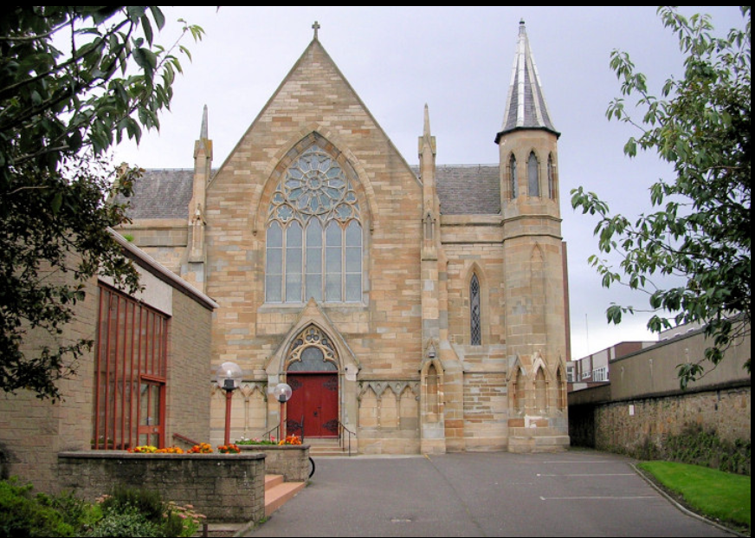

Newton Old Parish Church, Ayr Introduction

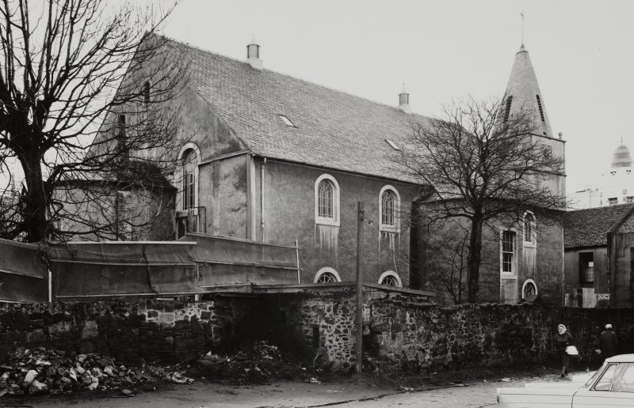

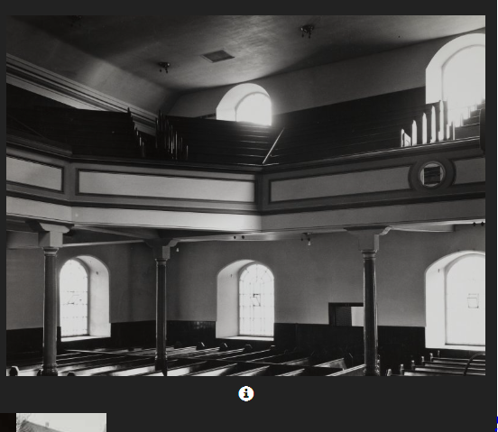
The church was built in 1777 / 78 as a Chapel of Ease for Monkton Parish Church. It was erected to full status in 1779 when Newton-on-Ayr became a parish. A manse and school were built in 1787. The manse was located off Waggon Road near Glebe Street and the school was adjacent to and in front of the church. The church was extended in the 1830s which encroached on the surrounding graveyard. In 1885 a Chapel of ease was built at North Newton (St James Church) which disjoined in 1904. Some alterations and minor additions were carried out about 1910. At the union with the United Free Church of Scotland it was renamed Newton Old Church. The church hall was at 33 New Road. The manse was demolished prior to 1936 to make way for redevelopments. In 1951 the church took over the mission in Limond’s Wynd (Wooden Kirk). It united with Newton New Church in 1962 and the church was closed. It was demolished in 1966/67 to make way for road improvements. The graveyard was exhumed and the remains moved to Wallacetown East Cemetery. Note that the tower which stands in the middle of the dual carriageway was not a church tower but was the Newton Freemans’ building. Access to the church was through the arch of the tower. The church hall in Peebles Street/New Road was incorporated into a tyre repair service.
Exterior Description
The building was aligned essentially east/west and had a hipped roof. It was rectangular with circular apses on the west, north and east and on the south a rectangular extension. These were probably all original. Sometime after 1909 the south wing was extended slightly westwards and a lean to extension added at the north east corned abutting the previous east apse. The west gable windows on either side of the apse entrance had round tops with the upper ones as dormers.
Interior Description
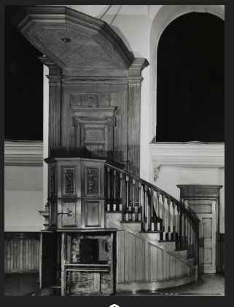
The World War 1 memorial of 1921 by James A Morris was moved to the Newton New Church when this church closed.
The Pavonazzo marble for this was by Galbraith and Winton and the bronze by Holmes and Jackson

Photographic survey by the Scottish National Buildings Record in July 1961.

- Name: Newton-on-Ayr Chapel of Ease--------------------Date: 1777

- Name: Newton-on-Ayr Parish Church----------------------Date: 1779

- Name: Newton Old Parish Church--------------------------Date: 1929

- Thomas Mears of London: Bell Founder -----------------Date: 1795

- James A Morris: Architect --War Memorial design------Date: 1921

- Holmes & Jackson Metalworkers - War Memorial------ Date: 1921

- Galbraith & Winton Stone Masons---War Memorial---- Date: 1921

Newton-on-Ayr Free Church, Ayr

Introduction

In 1843 most of the congregation left Newton-on-Ayr Church and met initially in the Congregational Church in George Street before building a new church just north of the Parish Church. A school was started in a building set back from Weaver Street and Damside. This had been a charity school building and it was purchased in 1845. A manse was acquired at 5 Montgomerie Terrace in 1850. In 1862 a new church was built to the rear (east) of the original church and the old church became the Free Church School. About 1876 when the schools were taken over by the Local Authority. The school was converted to a hall and extended to the north. This possibly happened about 1876 but certainly prior to 1896. In 1869/70 the hall was replaced. William Clarke, 1862. 3-bay, near rectangular-plan Gothic church with octagonal tower to outer right. Squared sandstone. Base course; string course; band course; blocking course; buttresses divide bays; arched colonnette recesses within.
W (ENTRANCE) ELEVATION: advanced central gabled entrance bay; central gabled entrance porch; timber door; tracery over; blind colonnade flanking; traceried rose window above; flanking buttresses rise to form pinnacles. Traceried window to recessed bay to left. Single window to recessed bay to right. 3-stage octagonal tower to outer right; arched colonnette recesses at 1st stage; blind central bay at 2nd stage; leaded arched openings at 3rd stage. Predominantly rectangular and arched windows (some sash and case windows to rear); coloured margins; some leaded work; modern exterior windows. Grey slate roof; stone skews.
INTERIOR: central organ placed behind pulpit (see notes); arched gallery arcade; ribbed ceiling; timber pews, gallery and furnishings; rose tracery window to entrance elevation; small rose window above organ. BOUNDARY WALL: coped boundary wall encloses site.

Statement of Special Interest
Ecclesiastical building in use as such. Built as Free Church. Formerly called Newton on Ayr New Church, the union of congregations with the demolished Newton on Ayr Old Church took place in 1962. Modern church hall to NW of site, dated 1971. Church organ rebuilt and completed 1967, using parts of organs from both Newton Churches by Hillsdon of Glasgow. Notable for its octagonal tower and blind recess and arcade detailing.

References

Bibliography
Ordnance Survey map, 1896 (evident); AYR ADVERTISER 8.5.1862 (information courtesy of Robert Close); John Strawhorn THE HISTORY OF AYR (1989), pp191, 218; Rob Close AYRSHIRE AND ARRAN (1992), p30.
- Title: Church founded ---------------------------------------------------Date From: 1843

- Title: Church built and school started--------------------------------Date From: 1843

- Title: Took over an existing school building------------------------Date From: 1845

- Title: New school built---------------------------------------------------Date From: 1856

- Title: New church built---------------------------------------------------Date From: 1862

- Title: School converted to a hall---The responsibility for schools was taken over by the local schools board-------- From: 1876 (approx)

- Title: hall extended to the north--------------------------------Date From: 1896 (pre)

- Title: Hall replaced-------------------------------------------Date From: 1969 To: 1970

Newton Wallacetown Church of Scotland, Ayr

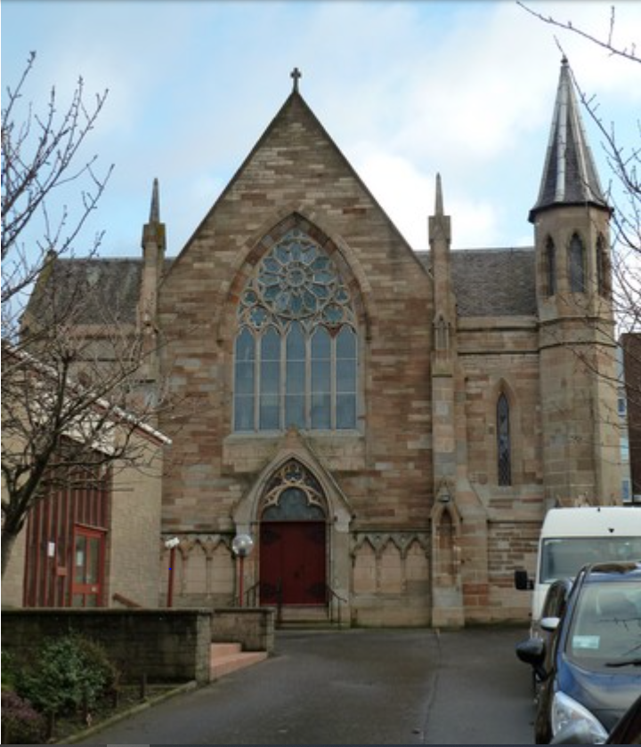

Introduction
The Church was rebuilt on the same site to a design by William Clarke of Clarke & Bell in Gothic style. In 1867 a free school was built. Manse in Prestwick Road. A Union with the United Presbyterian Church took place in 1900.

In 1905 Ayr Free Church took possession of the building and the United Free congregation met in Ayr Town Hall. The church was repossessed by the United Free congregation in 1907. A pipe organ was installed in 1923/24 by Hill, Norman & Beard.

In 1929 the Church united with the Church of Scotland and became Newton New Church. Prior to 1936 a hall was built to the front of the Church.

The Church united with Newton Old Church in 1962 and became Newton on Ayr Church. In 1971 the halls were replaced.

The Union with Wallacetown Church took place in 2010 and the Church was renamed Newton Wallacetown Church.
Exterior Description

The church lies essentially east/west and is a rectangular shape with a nave and two aisles. Slates are used on the roof. The building has coursed blonde sandstone on the west entrance front and uncoursed sandstone elsewhere. The entranceway on the west gable has a pitched hood and a blind arcade of three bays on either side. The main window is pointed lancet style containing five pointed trefoils and above a rose with twelve large and twelve small tapered sided pointed trefoils round a circle containing a round-lobed cinquefoil and with tracery adjacent to the outer circle. Between the lancets and the rose on each side are a circle containing a round-lobed hexafoil and a circle containing a round-lobed trefoil. To either side of the nave there are aisles. These terminate on the west with transverse gables which face north and south. The west face of the south aisle has long narrow lancet windows set high up whereas the west face of the north aisle has within a lancet window, two tall narrow pointed trefoils, a central pointed trefoil in the form of a dagger, two round-lobed trefoils in the form of an upside-down dagger and other tracery.
This aisle has a buttress on its far north corner. Between the nave and the aisles are stepped buttresses which have a niche at ground level and a smaller one higher up.
Both finish with a pinnacle. On the southwest corner of the south aisle is an octagonal tower with niches on the exposed sides at ground level and a blind pointed trefoil window. Above that there are pointed trefoil windows with rounded column jambs. The tower finishes in a slated spire. The outer sides of the aisles have rectangular windows at ground and gallery level. There is a small truncated lancet window at the west end of the north wall of the north aisle. The pitch of the aisle roofs is flatter than that of the nave. The east gable has a rose window consisting of a central wheel with ten “spokes” and outside that ten splayed pointed trefoils with circles at the outer points. Tracery completes the window. Below this window are two tall and wide lancet windows. To the rear there are church offices which were a later extension. The building is aligned north/south and abuts the east gable. It has a pitched roof, sash windows and a semi-circular topped entrance at either end.
The new hall partially obscures the church from the road and lies slightly to the north. It is built using reconstituted stone facing blocks and has a slated roof on part and a tiled on the main area. It has been extended and modified several times. Interior Description
The interior of the nave light and open with a u-shaped gallery on cast iron columns. The roof is plastered and painted between the groins. The two entrances under the west gallery are lancet style. The pulpit is on a platform at the east gable with the organ behind and above it. The remainder of the organ pipework is located at the east end of both the south and north aisles with the console located below the pulpit. The pipe organ by Hill, Norman & Beard was installed in 1923/24 and was rebuilt by Hilsdon of Glasgow in 1967. The rose window in the east gable with bright coloured glass in the central area and on the outer panes and floral patterns on the clear panes in between. The window on the west gable is filled with a mixture of clear and brightly coloured glass. The other windows are essentially in plain glass with a design brought out by the leading. The doors to the rooms at the east end of the church are timber with ornate paneling above. The gallery front is solid and is painted. The pews are arranged in three tiers facing east with those at the east end of the isles reoriented inwards. The wooden baptismal font is a memorial to a previous minister (c1928). The communion table in light oak has an arcade of three pointed trefoils and located in the centre one is the “IHS” in brass. There is a marble monument to Jane Peebles by Mossman (c1819), a war memorial in bronze and marble by James A Morris (1921) which came from the formed Parish Church, a bronze plaque to commemorate the union of Newton Old and Newton New Churches as well as other memorial plaques. There are also War Memorial tables from both Newton Old and Newton New Churches. The glass partition and doors in the vestibule were erected in 2000 as a millennium project.
- Name: Newton-on-Ayr Free Church-----------------------------------------Dates: 1862-1900
- Name: Newton-on-Ayr Free Church-----------------------------------------Dates: 1905-1907
- Name: Newton-on-Ayr United Free Church------------------------------Dates: 1907-1929
- Name: Newton New Church----------------------------------------------------Dates: 1929-1962
- Name: Newton-on-Ayr Parish Church-------------------------------------Dates: 1962-2010
- Name: Newton Wallacetown Parish church----------------------------Dates: 2010-NOW

- William Clarke of Clarke & Bell: Architects---Design of church-------- Dates: 1862

- Hill, Norman & Beard of London-- Pipe Organ Designers & Installers 1923-1924

- Hilsdon of Glasgow- Pipe Organ Designers & Installers-- Organ rebuild : ---1967

- Name: James A Morris---Role: Architect-- Design of War Memorial----------- 1921

- Name: Mossman of Glasgow: Monumental Sculptors- Monument design & sculpting------------------------------------------------------------------------------Dates: 1819 (about)

SITE ALTERNATIVE NAMES

- Name: Newton-on-Ayr Free Church------------------------------------------Date From: 1862

- Name: Newton-on-Ayr United Free Church-------------------------------Date From: 1907

- Name: Newton New Church-----------------------------------------------------Date From: 1929

- Name: Newton-on-Ayr Parish Church---------------------------------------Date From: 1962

- Newton Wallacetown Church---------------------------------------------------Date from 2010

SITE EVENTS
- Title: New church built : On same site-------------------------------------Date From: 1862

- Title: Union with the United Presbyterian Church: Delay due to the reallocation of church buildings-----------------------------Date From: 1907

- Title: Union with Church of Scotland---------------------------------------Date From: 1929

- Title: Hall built at the front of the church---------------------------------Date From: 1936

- Title: Union with Newton Old Church---------------------------------------Date From: 1962

- Title: Halls replaced--------------------------------------------------Date From: 1969 To: 1971

- Title: Union with Wallacetown Parish Church--------------------------Date From: 2010

Grateful thanks to Scottish Church Heritage Research (SCHR) and © Historic Environment Scotland. Scottish Charity No. SC045925

